American Isolationism (Post-World War One)
- Task Overview:
- Students will be able to explain why and how the United States moved to a policy of isolationism following World War One.
- Critical Abilities and Practices:
  - Analysis of Information, Experimentation and Evaluation
  - SSP 1, 7
- Aligned Standards:
  - A.H.HI.D.16- After World War One, the United States pursued efforts to maintain peace in the world. However, as a result of the national debate over the ratification of the controversial Treaty of Versailles and the League of Nations, the United States moved away from the role of world peacekeeper and limited its involvement in international affairs.
- Type and Purpose of Performance Assessment:
  - This is a constructed response. The purpose is to gather evidence of student’s ability to explain why and how the United States subscribed to the policy of isolationism by analyzing information and evaluating key historical concepts and documents.
- Instructional Support:
  - The teacher will provide direct instruction showing the complexity of the Treaty of Versailles and creation of the League of Nations which sparked a national debate over whether or not to stay out of future European affairs.
- Time/Schedule Requirements:
  - This task will take approximately two class periods (50 minutes each class). The goal of the first day is to provide background information on the Treaty of Versailles and the League of Nations. The second day will focus on the debate within the United States and completion of the constructed response.
- Materials/Resources:
  - Student instructions
  - “Gap in the Bridge” and “Interrupting the Ceremony” political cartoons
  - SCALE rubric
- Prior Knowledge:
  - United States involvement in World War One
  - Previous United States international involvement rooted in Imperialism (i.e. Spanish American War)
- Connection to Curriculum:
  - American Isolationism (Post-World War One) is designed to evaluate a student's understanding of significant American history vocabulary and how these terms were used in a larger historical context. By evaluating and analyzing these historical concepts students will be able to address why and how the United States choose a path of isolationism after World War One.
- Scoring:
  - Student work can be scored using a rubric
Rubric:
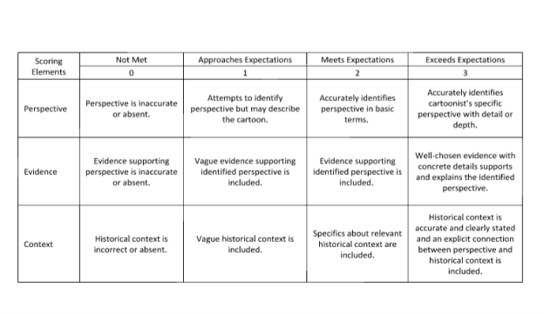

*rubric can be used to grade the political cartoon and newspaper article*

Daily Breakdown of Activities
 | Overview | Teacher Notes | AH.HI
Day 1 | Class discussion and information given about the United States involvement in World War One. Discuss the disillusionment with the war the how the world dealt with the carnage of trench warfare | - Students have previous knowledge of World War One if previous course was world history  - This review provides information necessary to the overall historical context of the U.S. and its relations with the rest of the world in 1919. | AH.HI.D.16
Day 2 | Class discussion about the Treaty of Versailles, the League of Nations, and the move towards isolationism. Students will answer the constructed response individually and create their political cartoon. | - Connect the idea of being isolated after a conflict to their own unique relationships with peers  - In small groups, students will be responsible for determining whether or not to join the League of Nations  - For visual impairments, enlarge the political cartoons on the board using technology or provide larger copies to students. If student is severely visually impaired or has a learning disability provide a description of the cartoons. | AH.HI.D.16

American Isolationism (Post-World War One)
Student Instructions:
To complete the following constructed response, use prior knowledge and the political cartoons provided below.

Political Cartoon #1
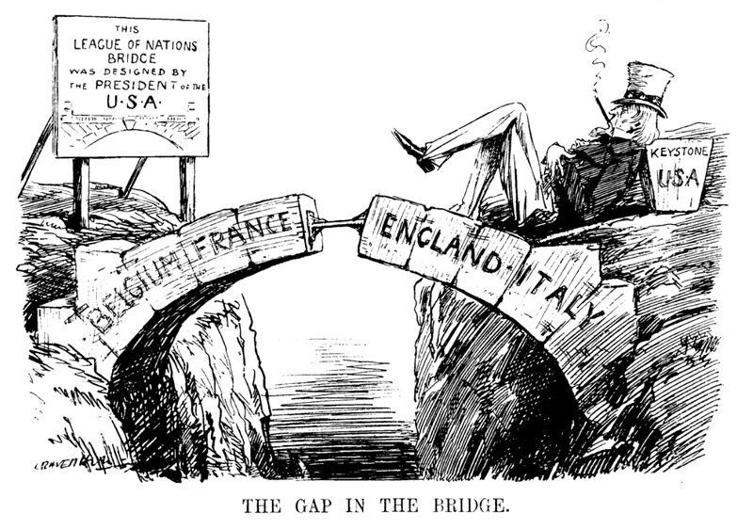
“The Gap in the Bridge” (1919) first published in Punch (a British Magazine) by Leonard Ravenhill

Political Cartoon #2
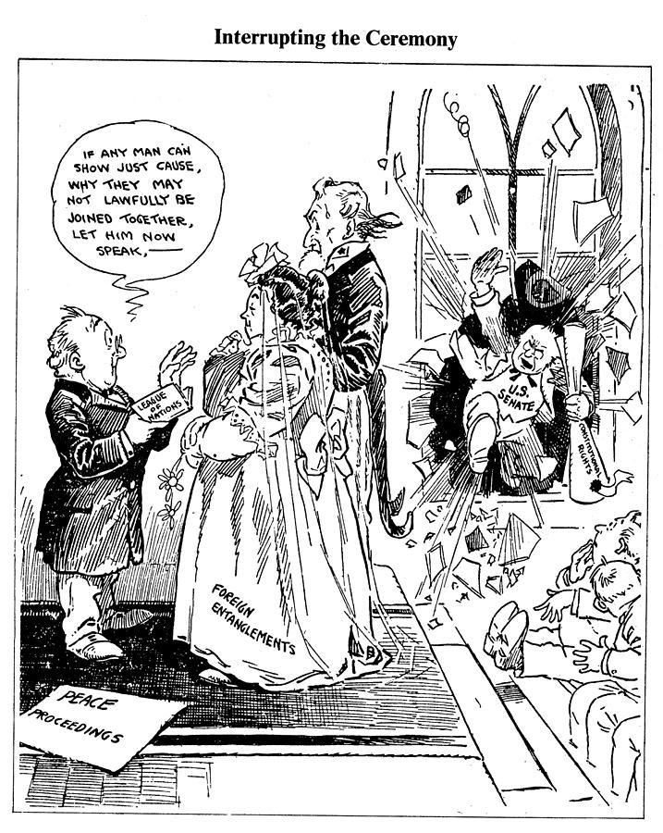
“Interrupting the Ceremony” (date unknown) published in the Chicago Tribune, authored by John T. McCutcheon

Document Based Questions

- Using the two political cartoons, A Gap in the Bridge and Interrupting the Ceremony, analyze the differing viewpoints of whether or not the United States should join the League of Nations.

- Why might a country like the United States want to remain an isolationist country following a world war? By maintaining its isolationist stance, what might be the immediate impact on Europe and the rest of the world?

- According to the political cartoons, A Gap in the Bridge and Interrupting the Ceremony, what would be the global impact of the United States not joining the League of Nations?

Performance Assessment:
Choose one of the following:
- write a newspaper article
- create a political cartoon

Newspaper Article Directions: On the page with lined paper, write a newspaper article that outlines the pros and cons of joining the League of Nations. Students should choose a point of view then construct an article discussing why their decision would be the correct path for the United States. Provide a title for your newspaper article.

Political Cartoon Directions: Use the Political Cartoon Template as a space to create your cartoon. Decide whether you are for or against the United States joining the League of Nations following World War One. Students should create a political cartoon that clearly depicts their position.
  - Cartoons should express a clear point of view (perspective).
  - Cartoons should include accurate historical context (mood or opinions surrounding an event or period in history).
  - Cartoons should include evidence that supports their opinion/perspective.
  - Cartoons should include a title and caption.

Newspaper Article Template
Title:

Political Cartoon Template

Scoring Rubric:

*rubric can be used to grade the political cartoon and newspaper article*

Student Sample A:
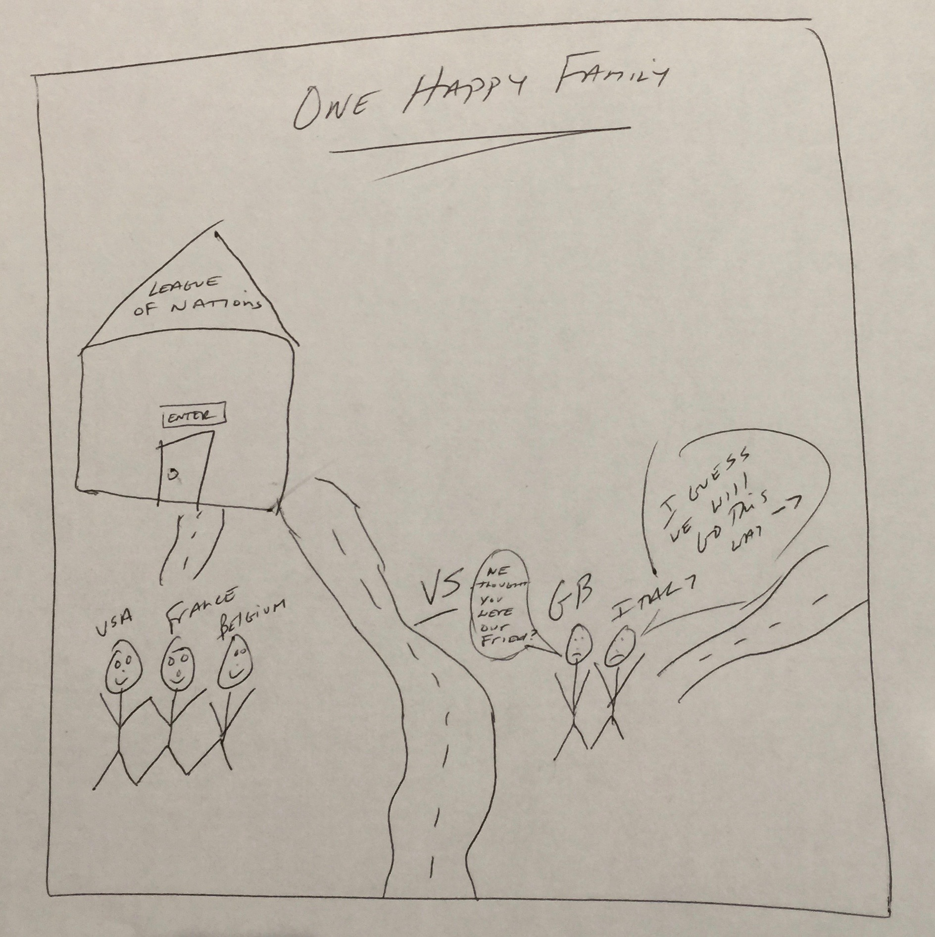

Scoring Sample: A
Maximum points per category: 3
Sample | Score | Description and Rationale
Perspective | 0 | The student has the United States allied with France and Belgium over Great Britain and Italy. Also, based on the figures walking into the League of Nations building the student inaccurately depicts the United States as a member of the League of Nations. So the perspective is inaccurate and does not show a view of whether or not the US should or should not joined the League of Nations.
Evidence | 0 | Evidence is not supporting a viewpoint and is inaccurate pertaining to the time period of isolationism following WWI.
Context | 0 | Historical context is absent and does not inform the reader about isolationism following WWI.

Student Sample B:

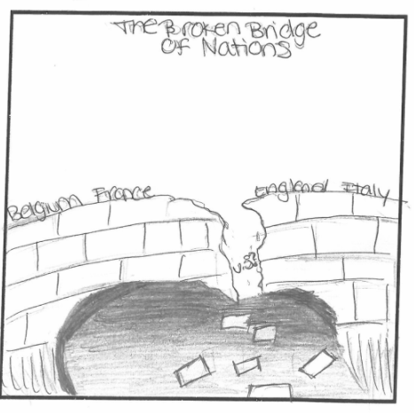

Scoring Sample B
Maximum points per category: 3
Sample | Score | Description and Rationale
Perspective | 2 | Cartoon accurately identifies a certain perspective pertaining to the US deciding not to join the League of Nations following WWI.
Evidence | 2 | Evidence is supporting the perspective that the US should have joined the League of Nations because without the US the strength of the League was diminished in deterring future world altercations.
Context | 2 | Two points were awarded for having relevant historical context. The student showed how the United States had to make a decision of whether or not to join The League of Nations and how that impacted relations with Europe. Specifics about relevant historical context are included in this cartoon because it includes the countries involved in the League of Nations.

Student Sample C:
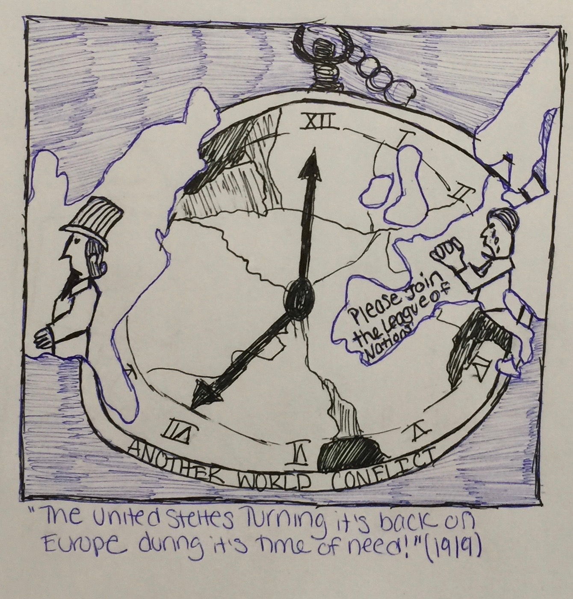

Sample Three (The United States Turning Its Back On Europe During Its Time of Need!):
Scoring Sample C
Maximum points per category: 3
Sample | Score | Description and Rationale
Perspective | 3 | Three points were awarded for well-chosen evidence with concrete details that support and explain the artist's perspective. It is clear that the student analyzed all political cartoons and understood the tone and perspective from the primary sources.
Evidence | 3 | The student received three points for accurate and clear historical context.
Context | 3 | The cartoon shows European nations begging the United States to join the League of Nations in 1919.

Student Sample D:

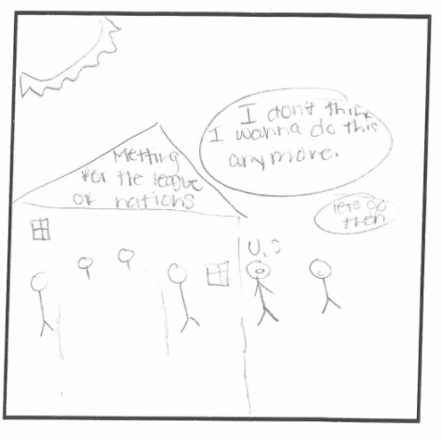

Scoring Sample D
Maximum points per category: 3
Sample | Score | Description and Rationale
Perspective | 2 | Accurately identifies perspective, that the US should not join the League of Nations, in basic terms without much analysis of the cartoon.
Evidence | 1 | Evidence is vague in supporting the identified perspective. Student is missing strong supporting evidence of the perspective that the US should not have joined the League of Nations.
Context | 2 | Specifics about relevant historical context are included because it includes specific countries involved in the League of Nations.

Student Sample E:
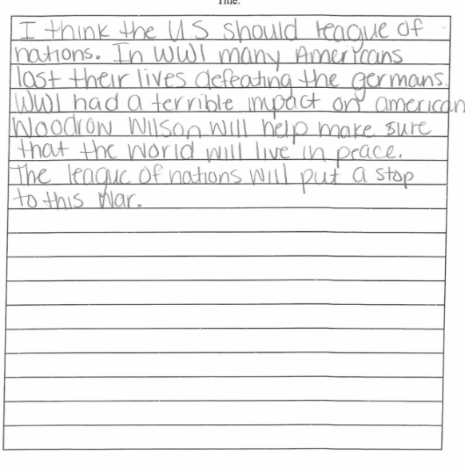

Scoring Sample E:
Maximum points per category: 3
Sample | Score | Description and Rationale
Perspective | 1 | Attempts to identify a perspective but only describes reasons the US may want to join the League of Nations
Evidence | 2 | Evidence is present because student provides information about WWI- Woodrow Wilson and Germany losing the war.
Context | 1 | Vague historical context is included in the response pertaining to the end of WWI.

Student Sample F:
We Are In!
The United States should not join the League of Nations because it wanted to be a strong nation. More powerful than the rest of the world. One of the political cartoons showed that we had to make a decision whether to join or not. That is why we decided to make the decision after the world war to join. I am glad we joined the League of Nations. They did not want to get involved in anything happening in other places.

Scoring Sample F
Maximum points per category: 3
Sample | Score | Description and Rationale
Perspective | 1 | This essay received one point for perspective. The student attempted to establish tone.
Evidence | 2 | One point was awarded for evidence because the evidence is vague but there was an effort to cite evidence based on a political cartoon.
Context | 1 | The student received one point for historical context because they made a connection between World War One and the League of Nations

Student Sample G:
US and The League of Nations
The United States should join the the League of Nations because it will help make the world safe again. I feel that the United States should join the League of Nations but not everybody wanted us to be in it. We should remain friends with other European countries because we need their support. Based on the political cartoon A Gap in the Bridge, it looks like the U.S. was hesitant of the alliances between European countries. It would be a good idea to join because we do not want to anger other strong countries like Great Britain and France. We should join the League of Nations because it will help us as a country.

Scoring Sample G:
Maximum points per category: 3
Sample | Score | Description and Rationale
Perspective | 1 | The student received two points for accurately identifying perspective in basic terms. Two points were awarded for evidence that supports the perspective.
Evidence | 2 | The student accurately cited A Gap in the Bridge but did not use the cartoon to enhance their argument.
Context | 1 | The student received two points for having relevant historical context. Evidence that they understood the relationship between United States and Europe following World War One was established.

Student Sample H:

Join and Unite!
The United States should join the League of Nations because we are one of the dominant forces in global relations. It would not look good for our country or an international associate to not include a world superpower like the US. Many Americans felt we should stay out of European affairs. This was evident during the war and after when dealing with the League of Nations. Interrupting the Ceremony shows that our legislative branch (US Senate) did not like the idea of the US becoming part of an international organization. Based on the cartoon A Gap in the Bridge, many believed that the US was the one missing piece to establish a great international organization. I agree with this cartoon because it is our role to help the rest of the world and maintain peace throughout Europe so that there would never be another world war.

Scoring Sample H:
Maximum points per category: 3
Sample | Score | Description and Rationale
Perspective | 1 | The student received three points for accuracy in perspective with detail and depth.
Evidence | 2 | Evidence from both political cartoons and accuracy in the interpretation of each cartoon earned the student three points in the evidence category.
Context | 1 | Historical context is clear and accurate throughout the essay. Connections and perspective were evident throughout all phases of the essay. The student made a strong claim that we should join the League of Nations and remained focused on the thesis throughout the entire essay.

