Status: World Power
- Task overview: Students will analyze and explain the circumstances in which the United States will gain more territories and also expand its status as a world power.
- Critical Abilities and Practices:
  - Analysis of information, experimentation and evaluation, and interpersonal interaction and collaboration
  - SSP 1, 2, 3, 7
- Aligned Standards:
  - AH.HI.D.15- As a result of overseas expansion, the Spanish-American war and World War I, the United States emerged as a world power.
- Type and Purpose of Performance Assessment:
  - This is a constructed response performance assessment. The purpose is to gather evidence and information of a student’s ability to analyze secondary and primary sources pertaining to the content connecting imperialism and the growth of the U.S. power around the globe.
- Instructional Support:
  - Teacher will provide some direct teaching to provide some in depth knowledge of the growth of American world power status.
- Time/Schedule requirements:
  - This task will approximately take 2 days to complete (50 minutes each class) in which the first day is to provide the background information and the second day to read the sources/produce the responses.
- Materials/resources:
  - Student instructions and constructed response
  - SCALE writing rubric
  - Video- US Imperialism
    - https://www.youtube.com/watch?v=BShvYeyMm_Y
- Prior Knowledge:
  - Understanding that industrialization led to Imperialism and need for more markets for American goods
  - Definition of Imperialism from the world perspective learned during world history
  - Analysis of political cartoons
  - Analysis of secondary sources
- Connection to Curriculum:
  - Status: World Power is designed to identify if students understand the connection between imperialism and how that expansion will lead to the growth of American power around the globe. Students gather smaller sections of the information and then connect this information on a larger scope.
- Scoring:
  - Student work can be scored using the SCALE writing rubric

Daily Breakdown of Activities
 | Overview | Teacher Notes | AH.HI
Day 1 | Class discussion about Imperialism and why the United States wanted to take over other territories. Students will be asked to brainstorm what parts of the world the United States desired to take over. Then create a list of the colonies or territories in which the United States had influence. Video | - This can be discussed in a large group setting but can also be broken down into smaller groups  - Use the student pages to gain background knowledge and examine the sources.  - For visual impairments, enlarge the political cartoons on the board using technology or provide larger copies to students. If student is severely visually impaired or has a learning disability provide a description of the cartoons. | AH.HI.D.15
Day 2 | Class discussion and overview of the territories. Then have the students work with a partner for the first 10 minutes on the constructed response. Once the 10 minutes is complete, have the students work independently on the constructed response. | - By allowing for some collaboration another critical ability is being employed in the classroom.  - Discuss in a large group how this perspective of American world involvement has persisted into modern times | AH.HI.D.15

Status: World Power
Student directions: Use the following documents to answer the questions below each source.
Secondary Source One: The Spanish-American War US. History textbook by Holt
The years following industrialization were a period in American history in which the United States began to expand their claims worldwide searching for favorable markets for American made goods. The expansion led to U.S. imperialism all around the globe in which there were bloodless acquisitions and also bloody altercations marking this period in American history. Since the United States closed the western frontier, Americans began focusing on the diminishing Spanish empire which still held Cuba (which is located very close to the United States border) by reading sensationalist newspaper articles about Spanish brutality against the Cubans. This brutality was captured in the concept known as yellow journalism that gave Americans an untrue version of events. Finally due to the explosion and sinking of the U.S.S. Maine which was being held in the port at Havana Cuba, the United States declared war on Spain. The Spanish-American war began in 1898 and was fought on two fronts in the Pacific and the Caribbean. Within four months the Spanish were defeated and the U.S. took control of the Philippines, Cuba, Puerto Rico, and Guam. The glory was given to Theodore Roosevelt and his “Rough Riders” who were volunteer soldiers who won a decisive battle during the war. The Spanish-American war propelled the United States to the status of a world power who became greatly concerned with international affairs. By being propelled to this world power, the United States begun to justify their reasons for adding territory into this new “American Empire.” The United States needed new markets and raw materials, they believed new colonies would increase the U.S. naval strength, new colonies would show the United States was a great nation (this is known as nationalism) and many Americans believed in white, Anglo-Saxon superiority.
- Analyze and explain how the Spanish American War helped the U.S. to emerge as a world power in the 1900s.

Secondary Source Two: America in the Pacific and East Asia
The United States was able to gain control in the Pacific, thus giving the U.S. more chances to trade with Japan and China. The following bullets describe the situation and the outcome of American expansion in the Pacific:
- The Philippines resisted American annexation but it was defeated in 1902.
- Hawaii--Americans had established sugar and fruit plantations and the Queen attempted to gain control over the American landowners. The landowners overthrew the Queen, and Congress voted to annex Hawaii.
- Other Pacific islands--Many islands were used as U.S. navy ports and are important during WWII.
China was seen as an important port and trading post for American goods because the U.S. was afraid of being shut out due to European spheres of influence. The Secretary of State called for an “Open Door Policy” in which all countries could trade freely with China. However, the Chinese people rebelled against this Western influence. The rebellion, known as the Boxer Rebellion, was crushed by foreign troops (which included the United States) because the lives of foreign people were being threatened. China was not the only Asian nation which became influenced by the West; Japanese trade also was opened by the Americans. The Japanese adopted many “western” ways and became the first Asian industrial power which led directly to the Japanese also becoming an imperialistic nation.
2. Analyze and explain how U.S. expansion in the Pacific and Asia helped the U.S. to extend its international influence on other countries.

Secondary Source Three: America and the Caribbean
The following graphic organizer provides information connected to American expansion in the Caribbean. Use this information to answer the question that follows.
Territory | Importance
Puerto Rico | - Became a possession of the US following the Spanish American war  - Still owned by the US even today  - Gained US citizenship in 1917 but it is still considered a territory not a state
Cuba | - After the Spanish-American War, Cuba became a protectorate under U.S. control.  - Cubans were forced to agree to allow U.S. businesses to stay on the island and have a lot of influence.  - This tedious relationship will lead to extreme dislike of the United States involvement.
Panama | - The people of Panama revolted with the backing of the United States if they agreed to allow the U.S. to build the Panama Canal.  - The U.S. government would control this Canal and its profits made by taxing the ships who used this canal to trade.

3. Analyze and explain how the United States gained control of the Caribbean territories listed in the above chart. Explain how this control helped the United States gain global power.

Source Four: Political Cartoon
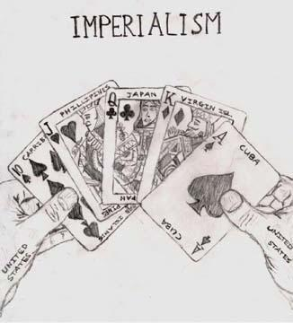
From: a digital history/usimperialism
4. Describe your interpretation of the above cartoon.

Performance Assessment:
Using the given sources above, analyze and explain how American overseas expansion helped America emerge as a world power.

Rubric:
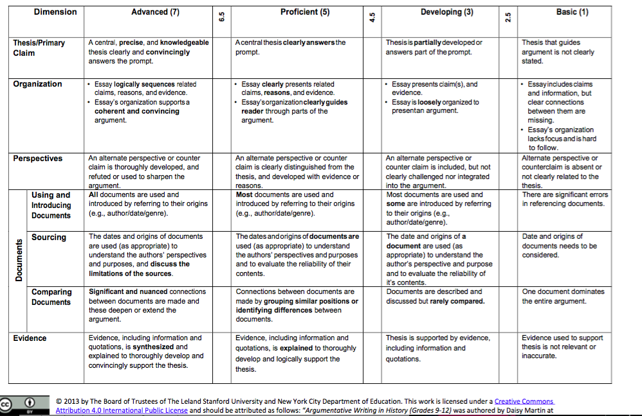

Samples of Student Work and Scoring
Student Sample A:
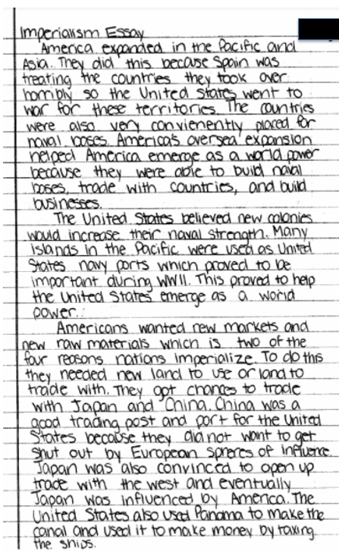
Sample A Continued:

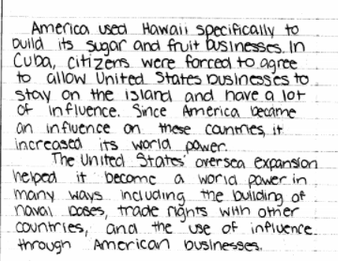

Scoring Sample: A
Max Points per category: 7
Sample | Score | Description and Rationale
Thesis | 5 | Thesis clearly answers the prompt clearly and precisely with multiple claims
Organization | 4.5 | Essay is clearly organized and guides the reader through parts of the argument.
Perspectives | 1 | Alternate perspective or counterclaim is absent or not clearly related to the thesis. Does not elaborate on alternative paths the US could have taken during this era.
Documents | 7 | All documents are used and student uses information from all the sources provided.
Evidence | 4.5 | Some of the information is explained fully but the thesis is supported by evidence from the documents.

Student Sample B:
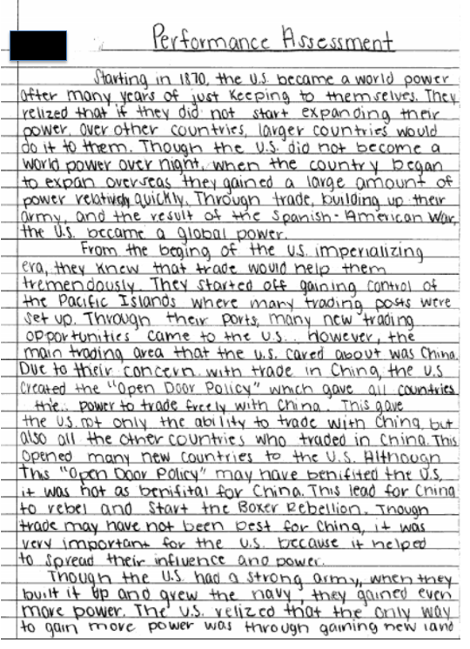

Sample B Continued
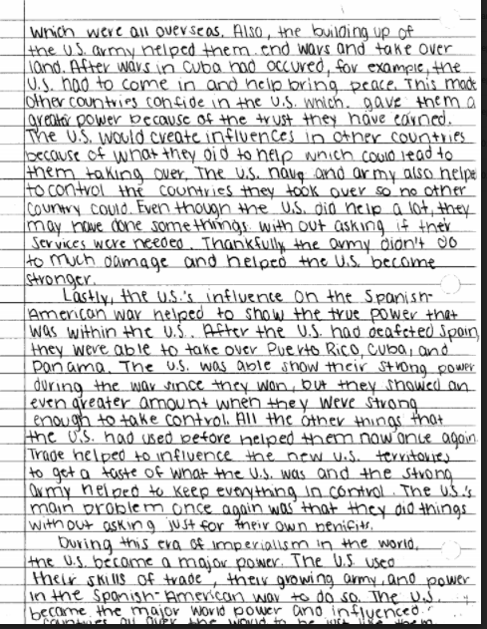

Scoring Sample: B
Max Points per category: 7
Sample | Score | Description and Rationale
Thesis | 7 | A central, precise and knowledgeable thesis clearly and convincingly answers the prompt explaining the US rise to power.
Organization | 7 | Essay logically sequences the essay related to the thesis in a coherent and convincing argument.
Perspectives | 3 | Alternative perspectives are present in the introduction but are not challenged or integrated into the argument explaining America’s rise to power.
Documents | 7 | Documents are used and student makes connections between the documents.
Evidence | 5 | Evidence is explained throughout the response to develop and logically support the thesis

Student Sample C:
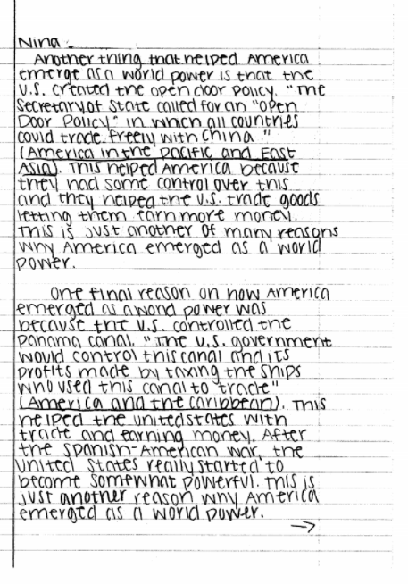

Sample C Continued
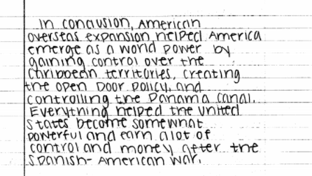

Scoring Sample: C
Max Points per category: 7
Sample | Score | Description and Rationale
Thesis | 7 | Thesis is accurate and addresses the prompt correctly
Organization | 7 | Essay is sequenced properly and is convincing
Perspectives | 1 | Alternative claim is missing
Documents | 3 | Documents are utilized but origins are not referenced.
Evidence | 5 | Thesis is supported by logical use of evidence but synthesis is missing

Student Sample D:
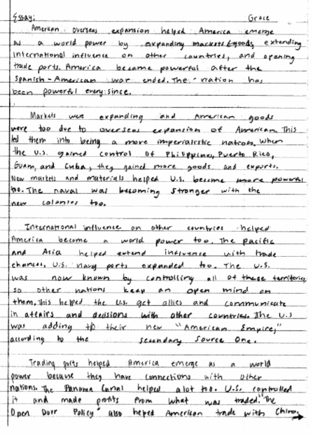
Sample D Continued
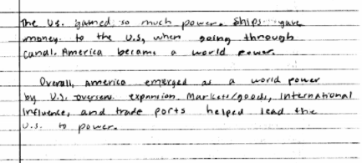

Scoring Sample: D
Max Points per category: 7
Sample | Score | Description and Rationale
Thesis | 3 | Thesis is partially developed as it is missing another piece of the claim.
Organization | 3 | Essay is loosely organized as the student attempts to follow the partially developed thesis.
Perspectives | 1 | Alternate perspective or counterclaim is absent from the response.
Documents | 5 | Most documents are used as secondary source material is cited and used throughout but not does make connections between the documents.
Evidence | 3 | Thesis is supported by evidence but due to partially developed thesis, evidence is lacking in fully supporting a thesis.

Student Sample E:
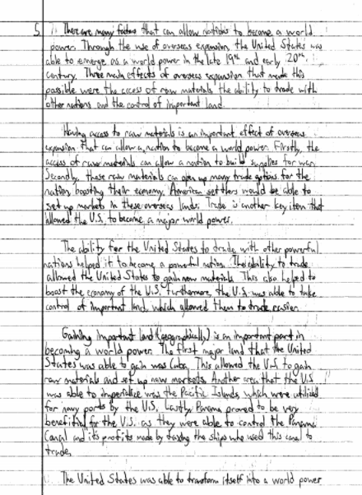
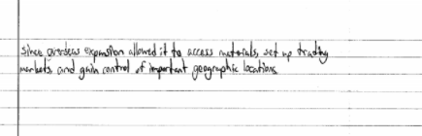

Scoring Sample: E
Max Points per category: 7
Sample | Score | Description and Rationale
Thesis | 7 | Thesis is accurate and addresses the prompt correctly
Organization | 7 | Essay is sequenced properly and is convincing
Perspectives | 1 | Lacking alternative perspective
Documents | 1 | Date and origins of documents is missing
Evidence | 5 | Thesis is supported by logical use of evidence but synthesis is missing

